GRADE 7 ACCELERATED · UNIT 2 · LESSON 5
Rational and Irrational Numbers on the Number Line
Worksheet 7A.02.05 ANSWER KEY

1. Sort the seven numbers into the table. Two of them carry a radical sign and are still rational.
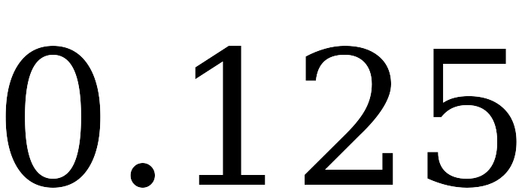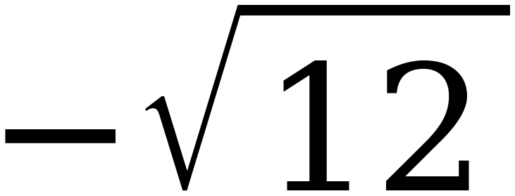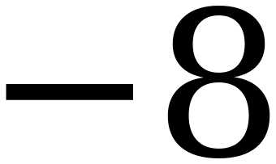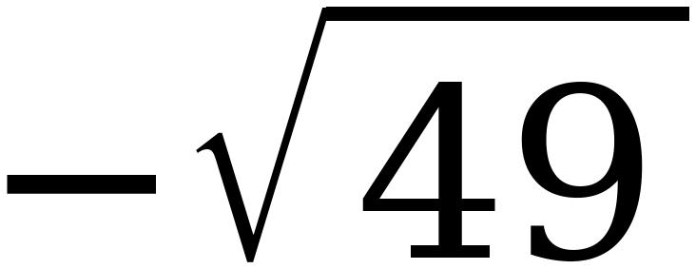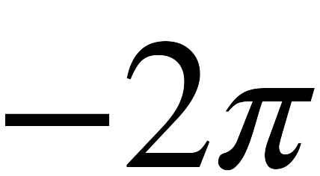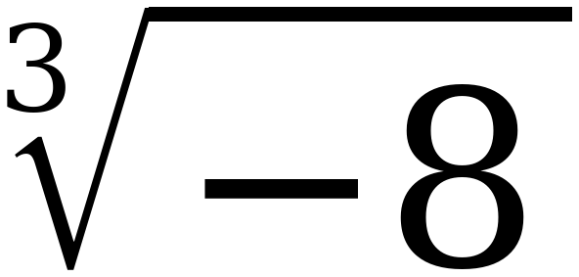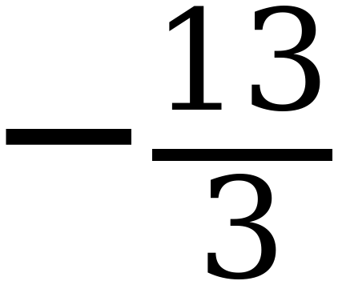
Rational | Irrational
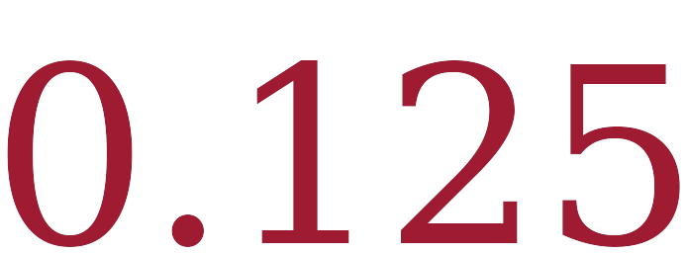 | 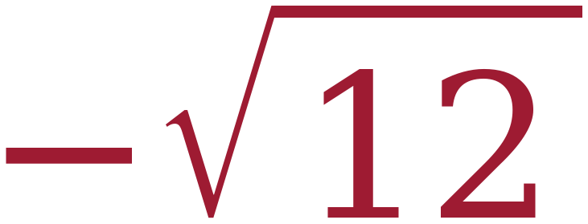
 | 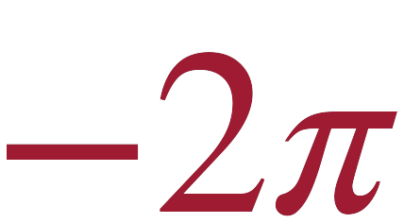
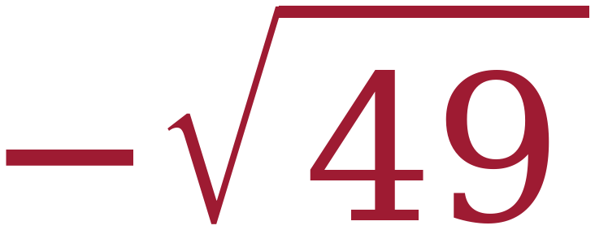
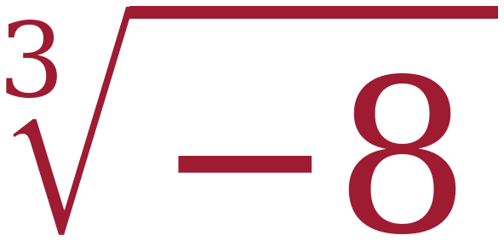
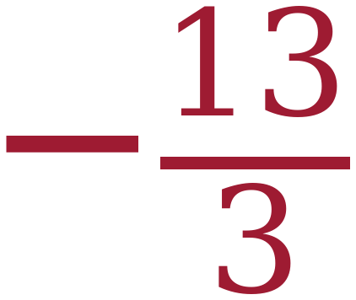

The two traps are −√49 = −7 and ∛−8 = −2. A radical sign does not make a number irrational — a radicand that is not a perfect square or cube does. −13/3 is printed as a ratio already, so it needs no work at all; the students who hesitate over it are reading the fraction bar as a warning sign.
For questions 2 through 7, compare each pair using <, > or =.
2. | 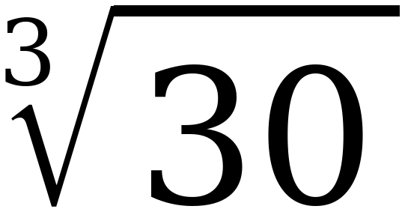 | < | 
3. | 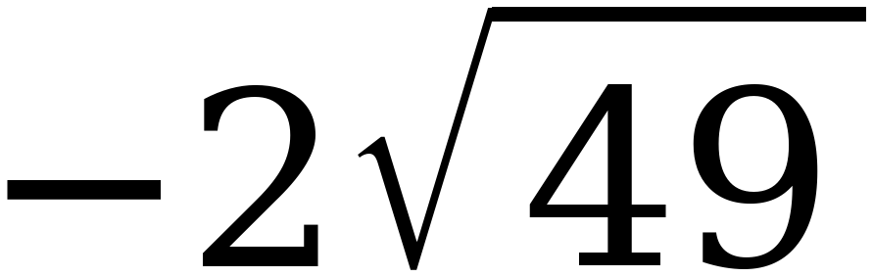 | > | −14.123…
4. | 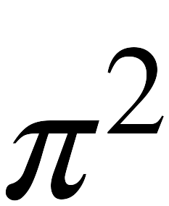 + 1 | > | 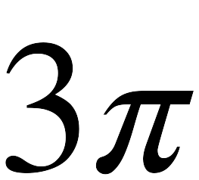
5. | 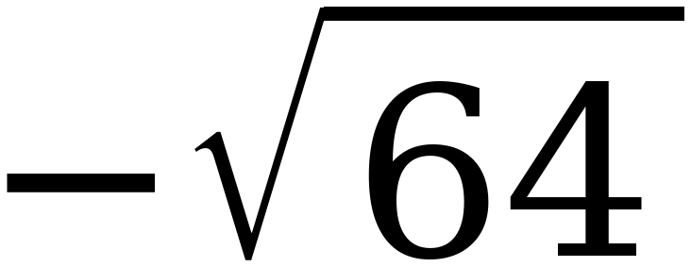 | < | 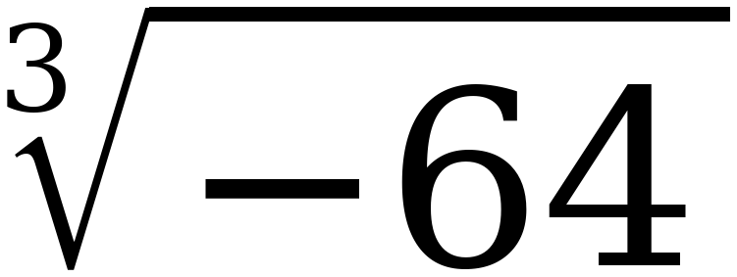
6. | 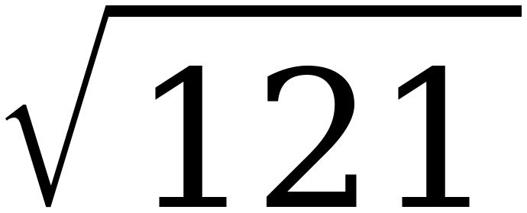 | = | 11
7. | 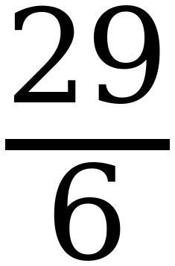 | < | 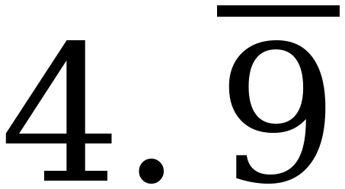

Question 3: −2√49 = −14, and −14.123… is further left, so −14 is the greater one. Question 7: 4.9 repeating is exactly 5, not “just under 5” — worth one sentence out loud. Question 6 is the only equality, and students who never write = should be asked why not.
8. Order the numbers from least to greatest, then plot and label each one.
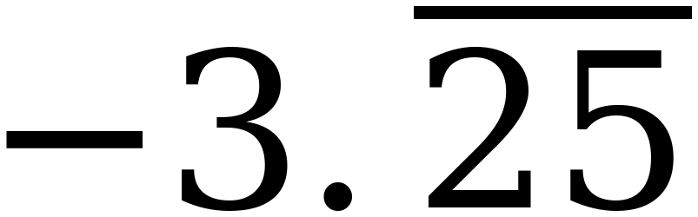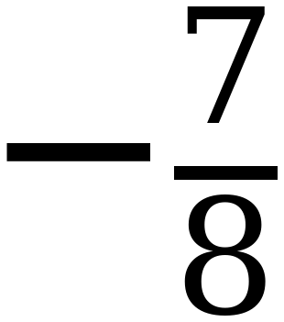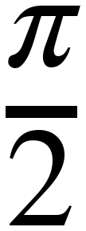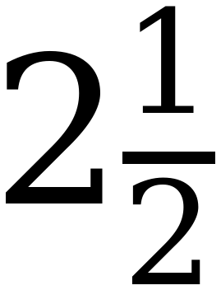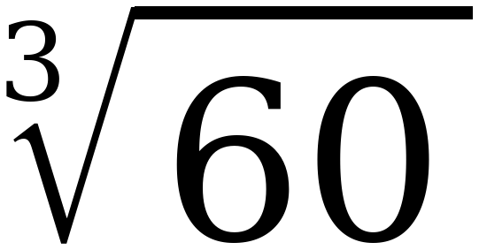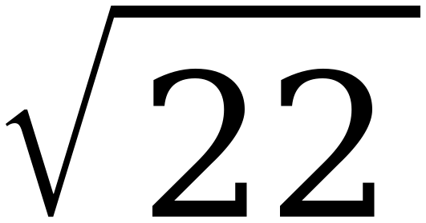
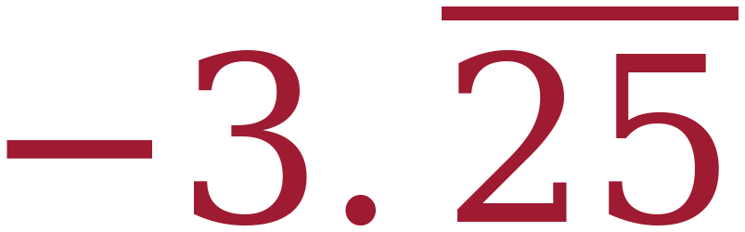 , −7/8 , ½π , 2½ , ∛60 , √22
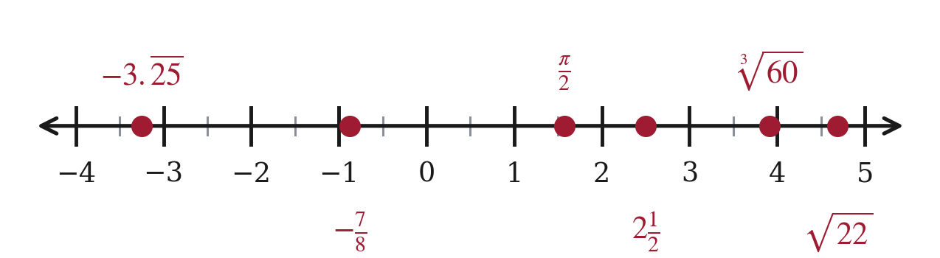
Decimal values: −3.2525; −0.875; 1.571; 2.5; 3.915; 4.690. Five land on or beside a half-unit mark. −3.25 repeating sits square between −3.5 and −3, and a point deliberately placed midway between two ticks is easier to mark than one that is almost on a tick.
9. Order the numbers from least to greatest, then plot and label each one.
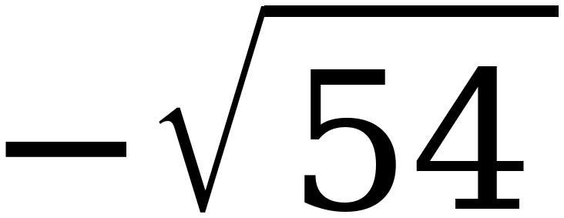 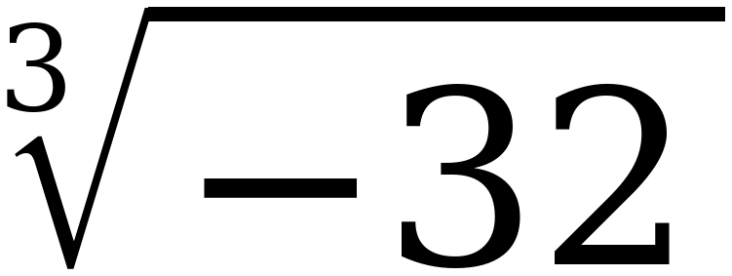 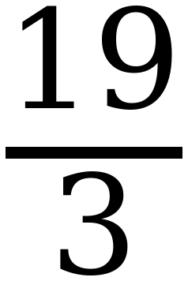 7.4
−√54 , −2π , ∛−32 , 19/3 , 7.4
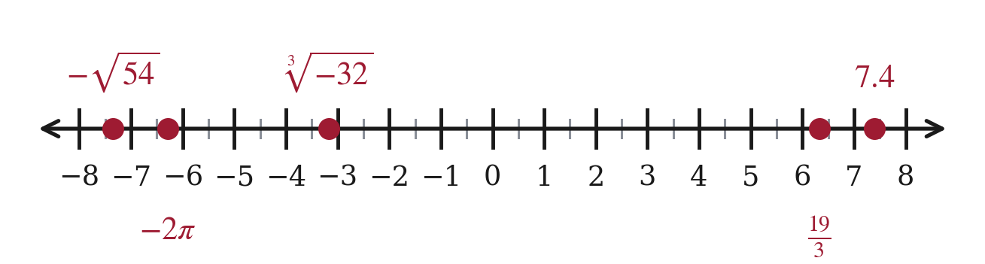
Decimal values: −7.348; −6.283; −3.175; 6.333; 7.4. The two negatives at the left are the ones to check — a student who puts −2π first has ordered by size instead of by position.
10. Which is greater, or ? Explain how you decided, and say what a student who answers the other way is doing wrong.
−2π is greater. −√49 = −7 and −2π ≈ −6.28, and −6.28 sits to the right of −7.
A student who answers −√49 is comparing 7 against 6.28 and forgetting the sign. With negatives, the number that looks bigger is the smaller one.
This is the misconception Math Nation names for this benchmark and it is worth a minute of class time. On a number line, further left always means less.

